Python Operators
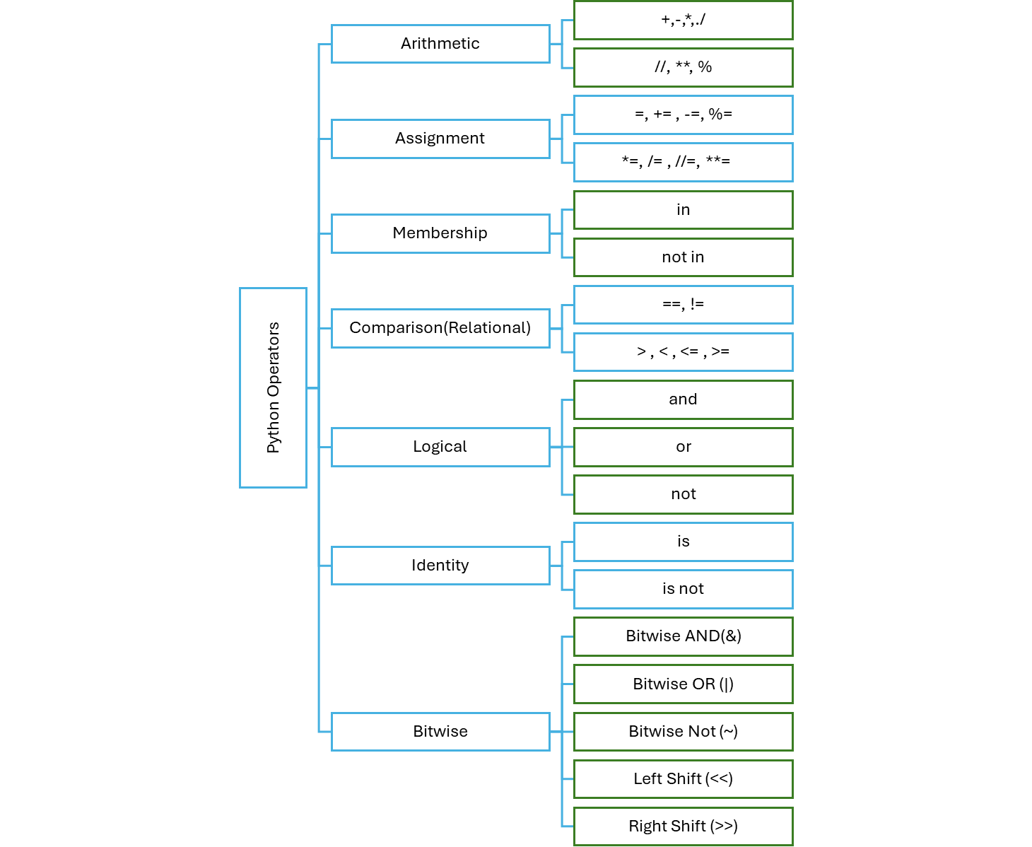

What are Operators in Python?
Operators are special symbols or keywords that perform operations on variables and values.

1. Arithmetic Operators
Used to perform math operations:
Operator | Description | Example | Result
+ | Addition | 5 + 3 | 8
- | Subtraction | 10 - 4 | 6
* | Multiplication | 2 * 3 | 6
/ | Division (float) | 10 / 4 | 2.5
// | Floor Division | 10 // 3 | 3
% | Modulus (remainder) | 10 % 3 | 1
** | Exponent (power) | 2 ** 3 | 8

Example:
milk = 1.5
sugar = 2
total = milk + sugar
print(total) # Output: 3.5

2. Assignment Operators
Used to assign values to variables.
Operator | Description | Example | Equivalent To
= | Assign value | x = 5 | —
+= | Add and assign | x += 3 | x = x + 3
-= | Subtract and assign | x -= 2 | x = x - 2
*= | Multiply and assign | x *= 4 | x = x * 4
/= | Divide and assign | x /= 2 | x = x / 2
//= | Floor divide and assign | x //= 3 | x = x // 3
%= | Modulus and assign | x %= 3 | x = x % 3
**= | Power and assign | x **= 2 | x = x ** 2
Example:
speed = 60
speed += 10
print(speed) # Output: 70

3. Comparison Operators
Used to compare values. Returns True or False.
Operator | Description | Example | Result
== | Equal to | 5 == 5 | True
!= | Not equal to | 4 != 3 | True
> | Greater than | 6 > 2 | True
< | Less than | 3 < 1 | False
>= | Greater or equal | 5 >= 5 | True
<= | Less or equal | 7 <= 6 | False
Example:
age = 18
print(age >= 18) # Output: True

4. Logical Operators
Used to combine conditions.
Operator | Description | Example | Result
and | True if both are True | True and False | False
or | True if at least one is True | True or False | True
not | Reverses the result | not True | False
Example:
rain = True
umbrella = False
print(rain and umbrella) # Output: False

5. Identity Operators
Used to check memory location of objects.
Operator | Description | Example
is | True if both are same object | a is b
is not | True if not same object | a is not b
Example:
x = [1, 2]
y = x
print(x is y) # Output: True

6. Membership Operators
Used to check if a value exists in a sequence (like list, string, etc).
Operator | Description | Example | Result
in | True if value is present | "a" in "apple" | True
not in | True if value not present | "z" not in "apple" | True
Example:
fruit = "banana"
print("b" in fruit) # Output: True

Practice Questions

Arithmetic Operator Questions
- A vegetable shop sold 4 kg of onions and 3 kg of potatoes. Onion is ₹40/kg and potato is ₹30/kg. Calculate the total bill.
- A pizza costs ₹250. If a customer buys 3 pizzas, calculate the total amount.
- A bus covers 240 km in 4 hours. Find the average speed using division.
- A water tank has 350 liters and is filled evenly over 7 hours. How many liters per hour were added?
- A student got 85 marks out of 300. What is the percentage?

Assignment Operator Questions
- The price of petrol per litre is ₹100. Increase it by ₹10 and store the result. What is the final price?
- A user has 500 reward points. They earned 200 more points. Update the total using +=.
- A car was moving at 90 km/h. Reduce its speed by 20 using -=.
- Set an initial counter to 1. Multiply it by 5 using *= and print the result.
- A company has 100 shares. Each share doubles in value. Update using **=.

Comparison Operator Questions
- A student got 45 marks. Check if he passed the exam (passing marks is 40).
- A mobile is priced at ₹20,000. Check if it is costlier than ₹25,000.
- Compare two bank account balances: acc1 = 10000, acc2 = 10000. Are they equal?
- You are 17 years old. Can you vote (if age required is 18)?
- If a person can swim or not , make code for this (answer will be in true or false format)

Logical Operator Questions
- You have a gym membership and are 18+. Check if you can access the premium zone.
- Your age is 19, and your height is 5.6ft. You can join the army if you're over 18 or taller than 6ft. Check the eligibility.
- You are not a registered user. Use not to check if not is_registered gives True.
- has_license = True, has_helmet = False. Can you ride the bike (only if both are True)?
- A person has paid fees or got a scholarship. Check if they can attend the class.

Identity Operator Questions
- a = [1, 2, 3], b = a. Check if a is b.
- x = 50, y = 50. Are x and y referring to the same object?
- x = [10], y = [10]. Are they the same object in memory using it?
- Create two variables with the same string and check identity.
- Make two variables: one assigned to a list, and one assigned to the same list. Use is not to check if they're different.

Membership Operator Questions
- Is the letter "a" present in "watermelon"?
- Check if "z" is not in "pineapple".
- fruits = ["apple", "banana", "cherry"]. Is "banana" on the list?
- sentence = "The quick brown fox". Is "quick" a part of the sentence?
- numbers = [2, 4, 6, 8]. Check if 5 is not in the list.

